**irevolution : A Data-Driven Exploration of Apple’s iPhone Impact in India**

**Introduction :**

The world has changed as a consequence of the increasing use of smartphones, which have improved communication, connected people, and revolutionized many different businesses. With its main product, the iPhone, capturing markets around the world, Apple Inc. has emerged as a prominent player among the top smartphone makers. India, one of the economies with the greatest economic growth, has seen a tremendous increase in smartphone usage, making it an interesting market to study the effects of Apple's iPhone.

The smartphones uses of insights of the world in the improved by the usage of marketing of dashboard and story of the application of Apple’s iPhone in India. We employed in the tool bar.

**1.1 Overview:**

Apple’s local market share in the smartphone market is also expected to grow. According to Singh, Apple could ship up to 9 million iPhones in India this year. - up nearly 40% from the 6.5 million iPhones that it shipped last year.

**1.2 Purpose:**

* Apple is contributing to the nation’s industrial growth, inculcating technological innovation, and creating thousands of jobs.

* A combination of the iPod, a revolutionary mobile and a breakthrough Internet communicator.

**Problem Statement & Design thinking:**

The overall problem at Apple Inc. is a stagnant iPhone growth problem due to decreased innovation and marketing efforts. Apple has hit a static point in its growth and continues to lose market share to its global competitors while trying to recover and invent the next big product (Seeking Alpha, 2017)..

**Design thinking:**

Steve Jobs returned to Apple in 1997, and he changed the vision of Apple by applying design thinking principles. The same strategy is being practiced by the brand even today.

* 1. **Empathy map:**

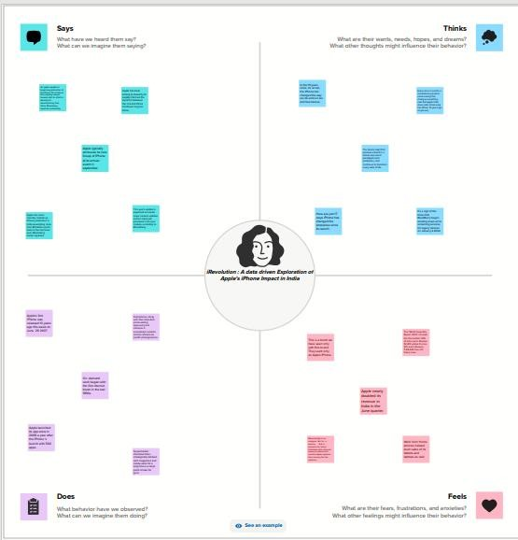

* 1. **Ideation and Brainstorming:**

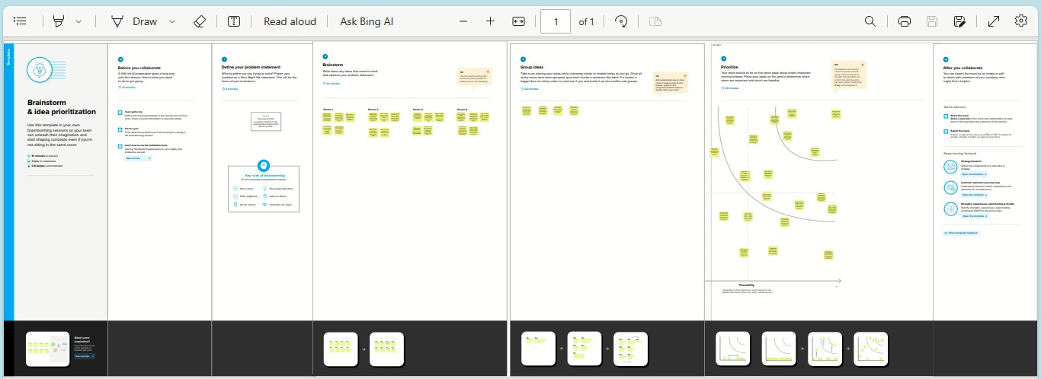

**3.Result:**

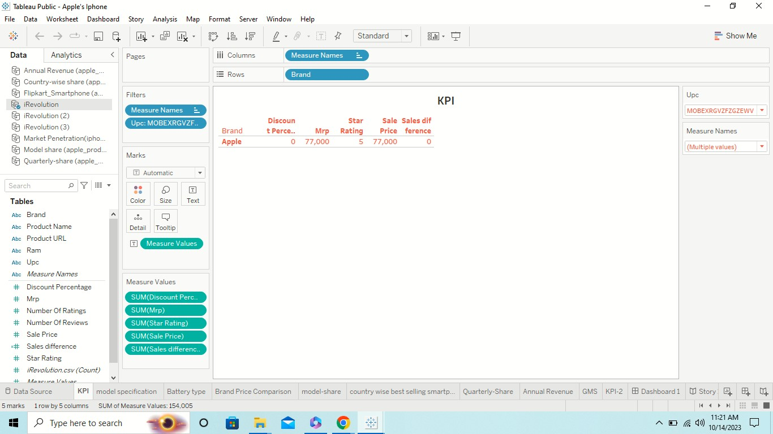

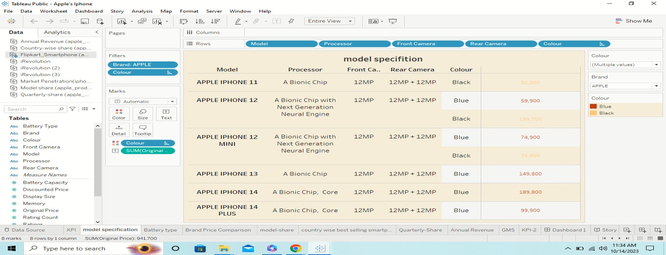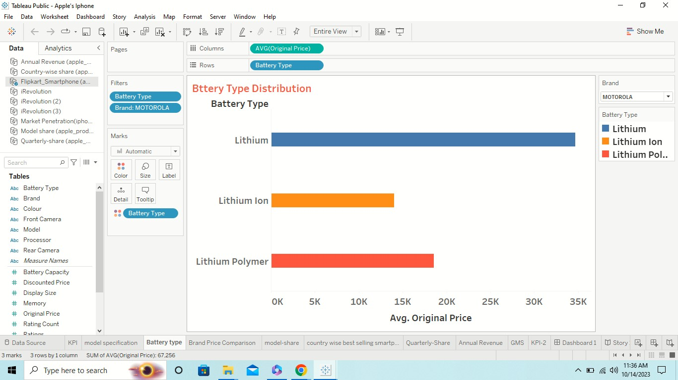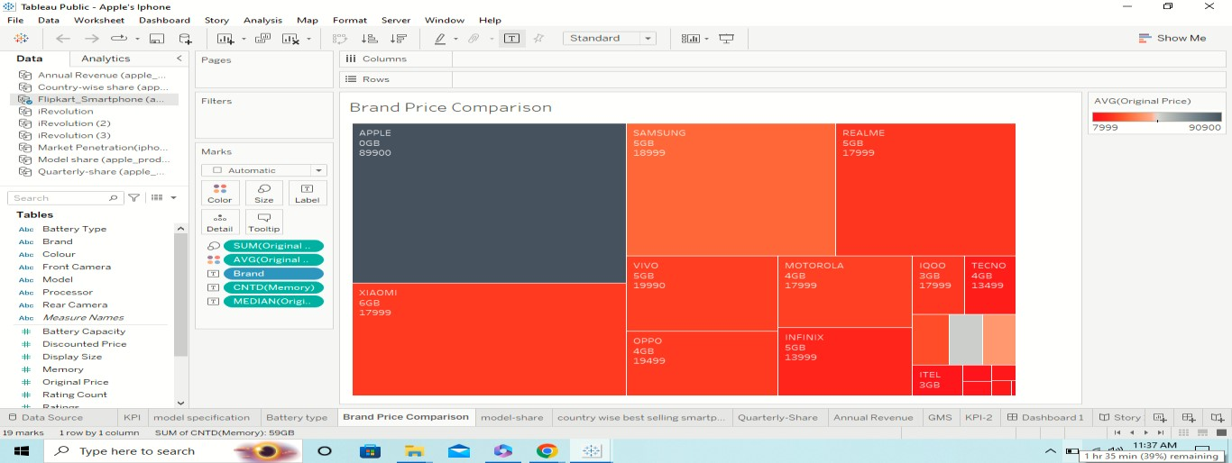

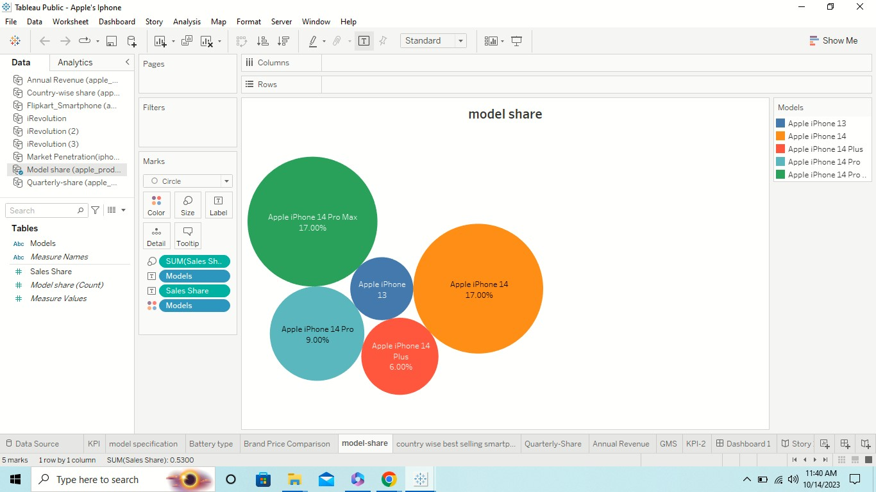

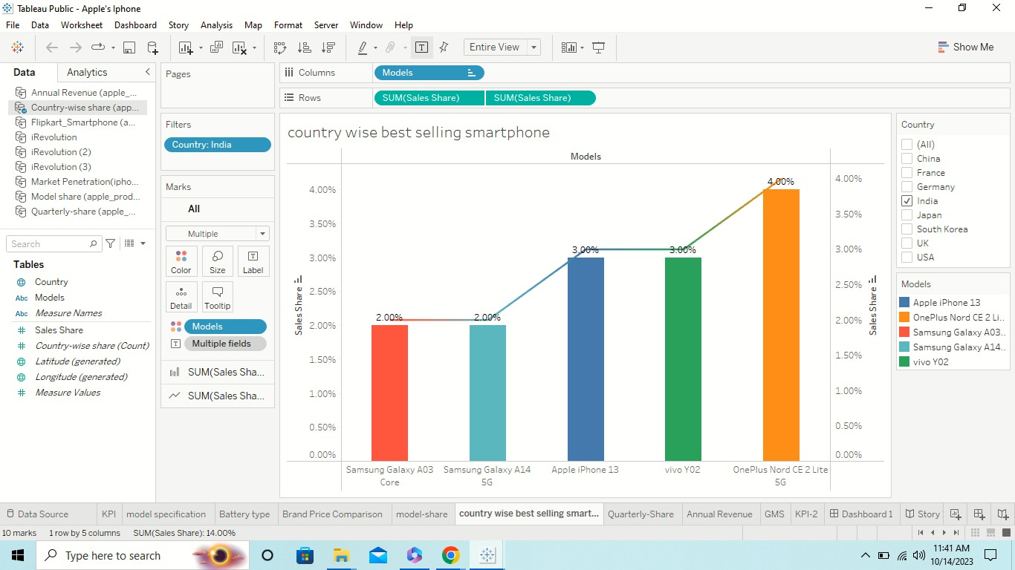

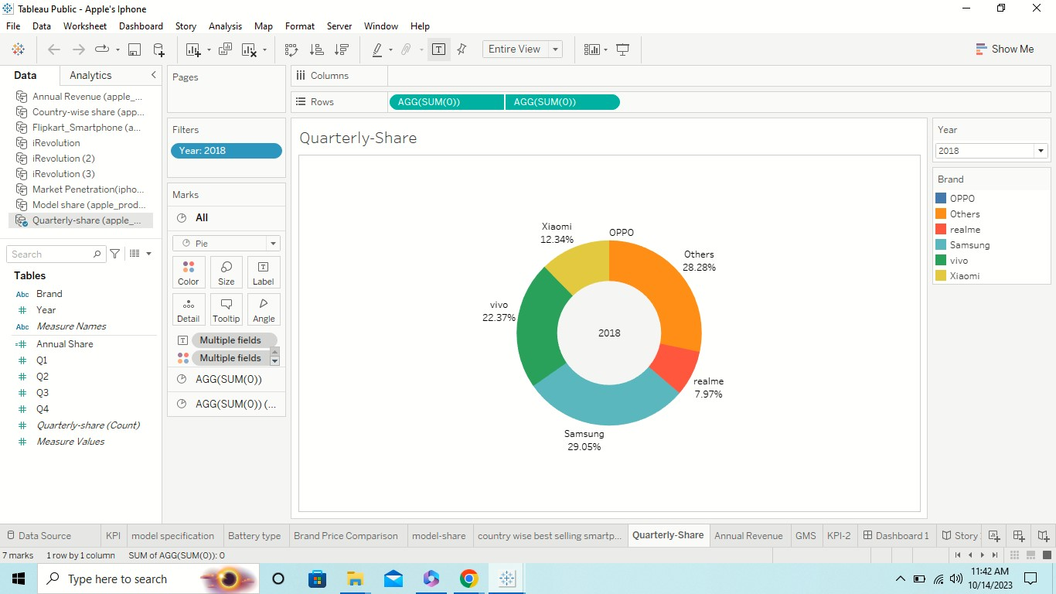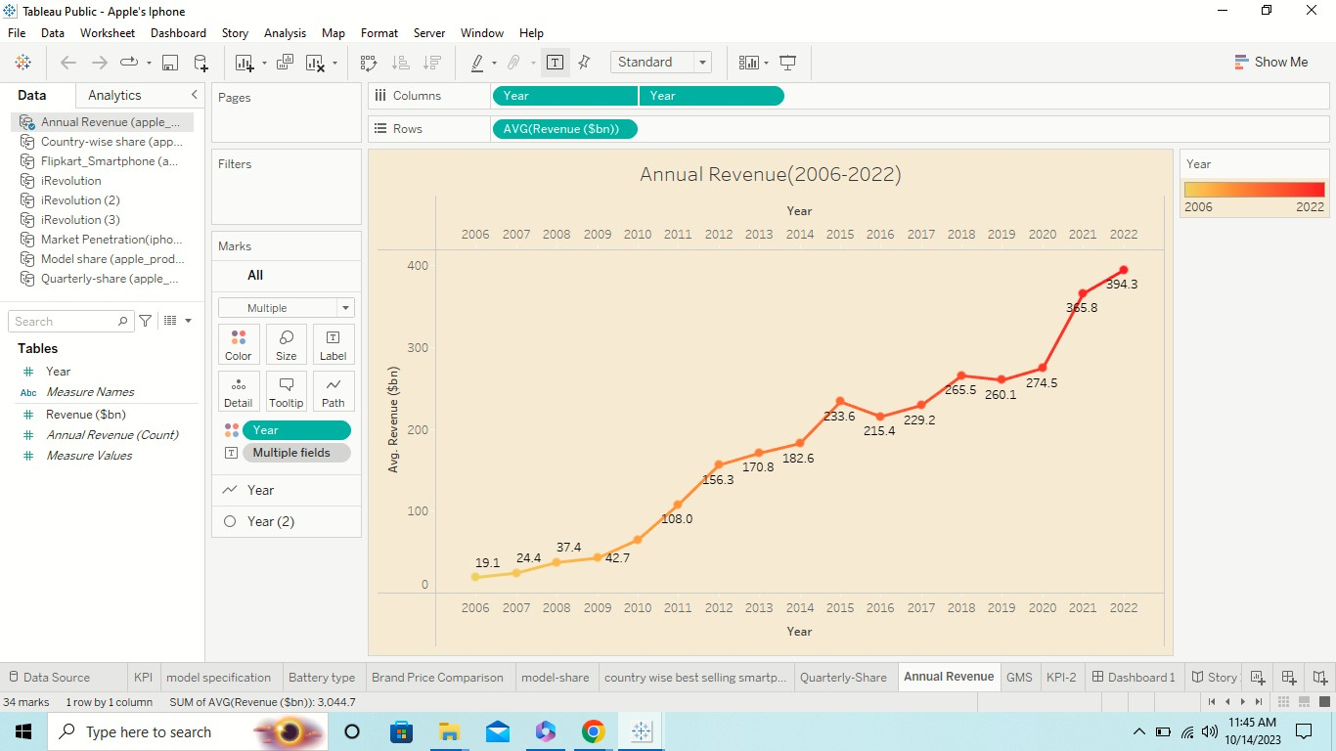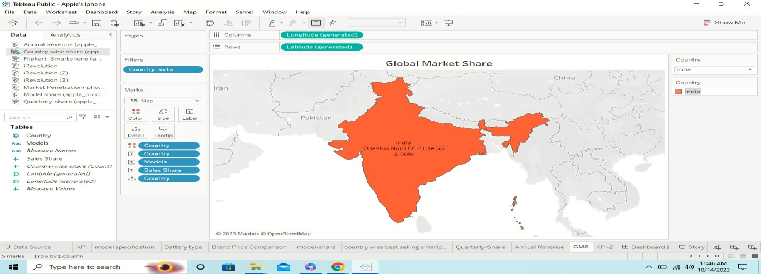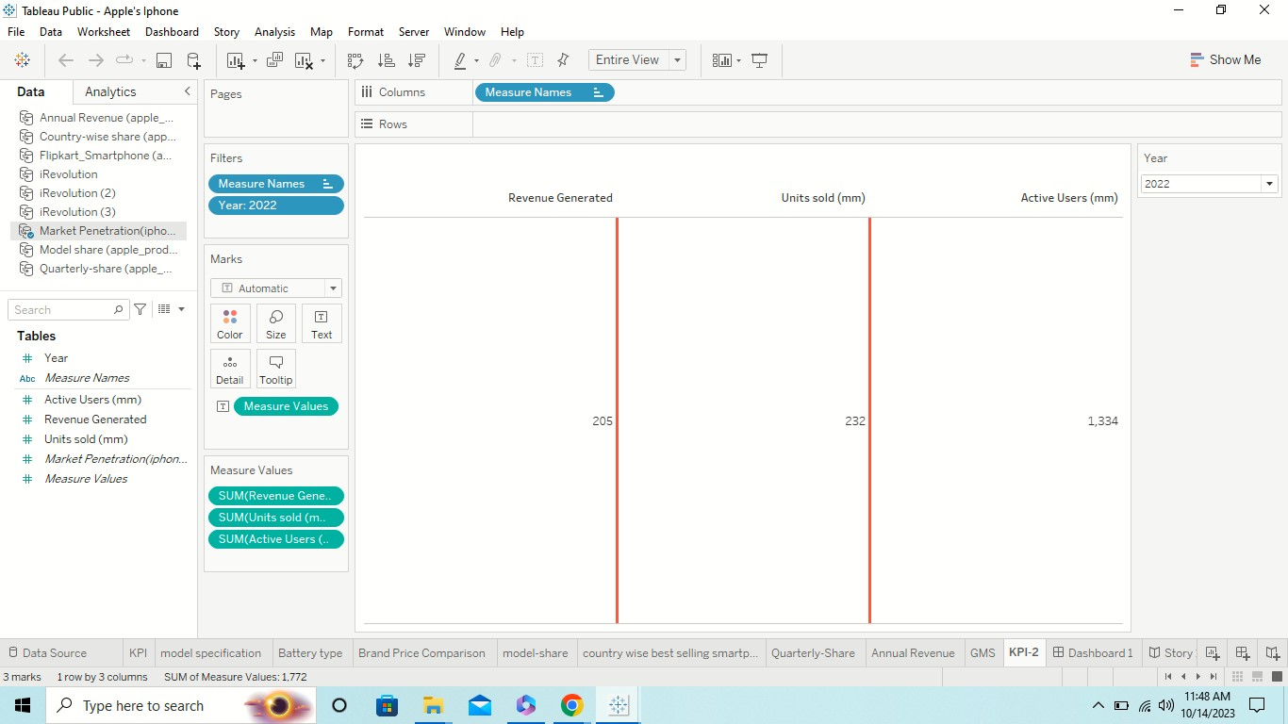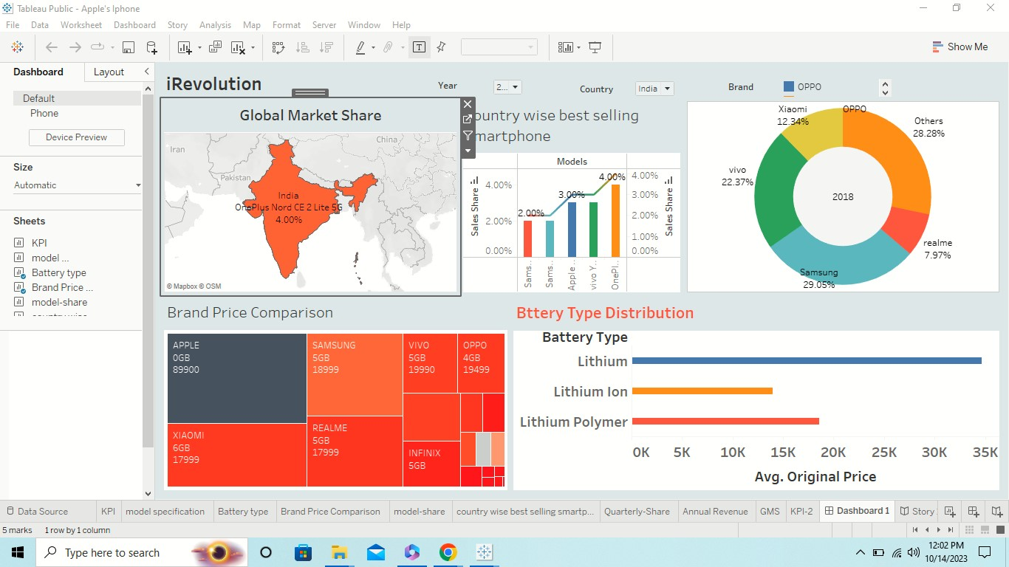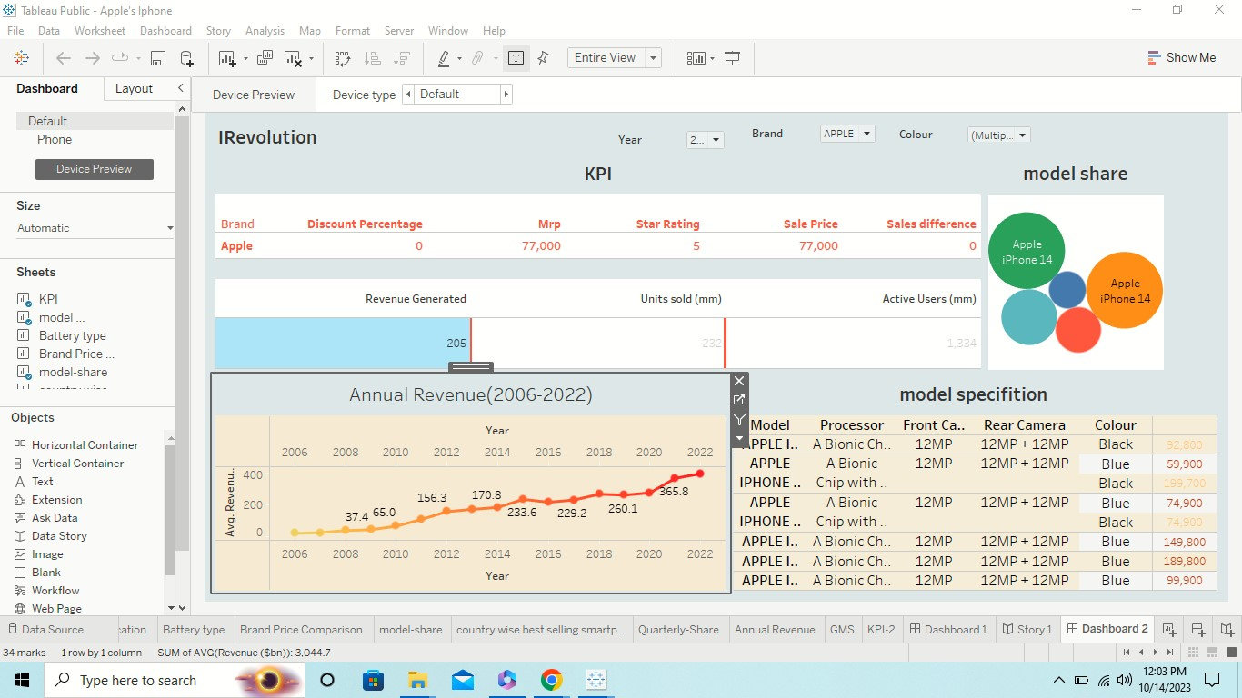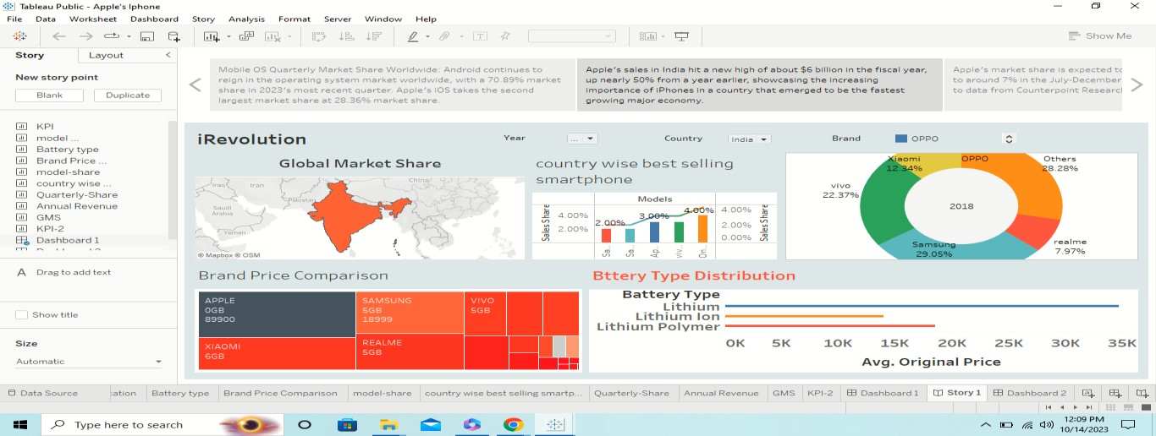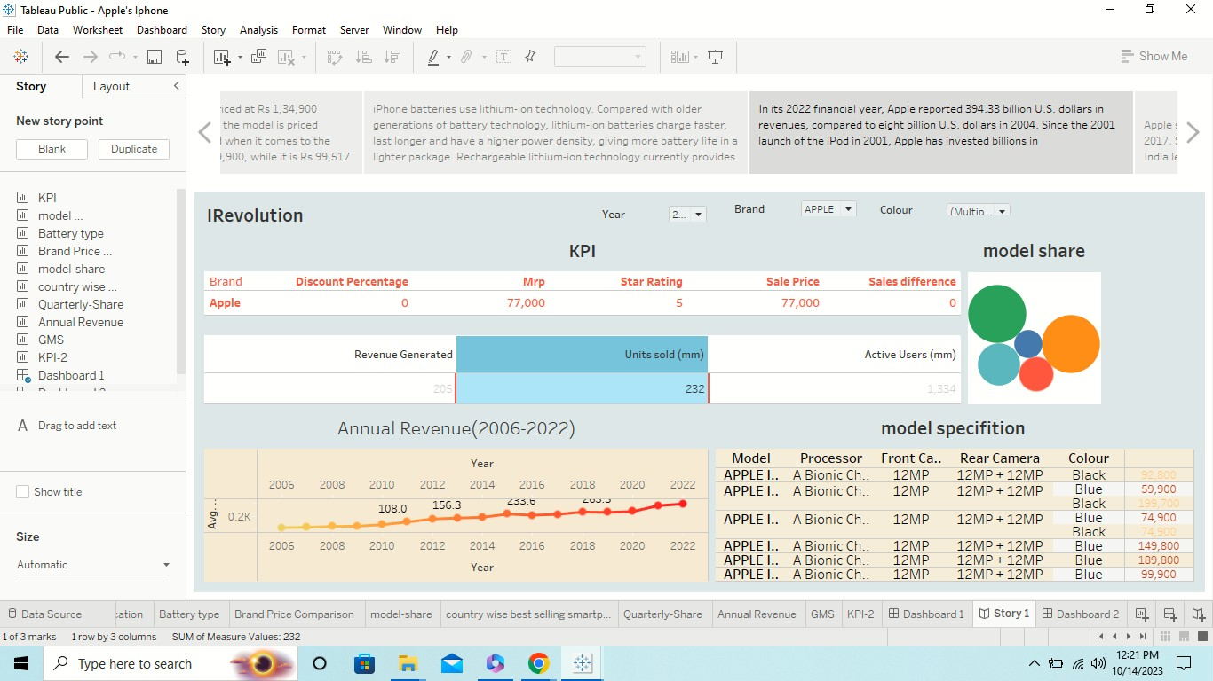

**4.Advantage and Disadvantage:**

* **Advantage:**

Apple phones are known for their ease of use. Their usability comes from simple operating logic: all the apps are launched from the home screen. All the settings, for example, can be found under one menu.

* **Disadvantage:**

* Not flexible only supports iOS devices. Not open source.
* The main disadvantages of using iOS are costly apps and no widget support.

 You cannot change your ringtone but there are many alternatives to do that.

 Apple restricted the connectivity with iTunes.

 Devices are very pricey.

**5.Application:**

Apple Application Support is a software component developed by Apple Inc. It is primarily used to ensure compatibility and provide necessary frameworks for various Apple applications run.

**6.Conclusion:**

Apple and the iPhone is a great example of **a corporation making what the consumer wants in a global market**. With limited companies competing.

**7.Future Scope:**

Apple in India: India is expected to assemble up to half of the world's iPhones by 2027, from 7 percent now, as Apple looks to reduce manufacturing dependence on China. India is also important for the US company to extend its market reach.

